1)Execute the script shown in the video.
Step 1: Create Project Folder
Open VS Code → Create folder:
Terraform_basic
Inside it create:
main.tf
variables.tf
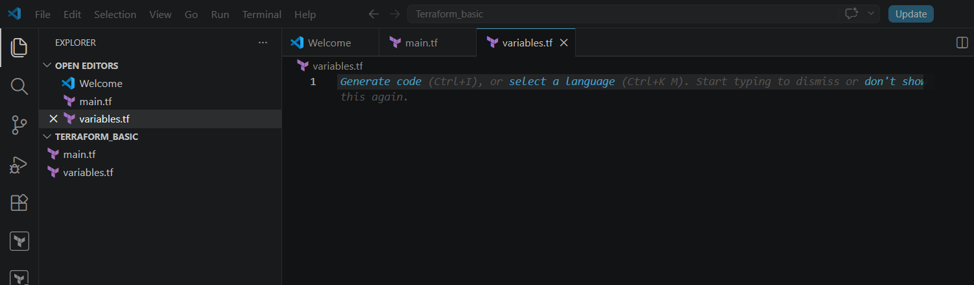

Step 2: Write main.tf
resource "local_file" "my_pet" {
filename = var.filename
content = var.content
}
resource "random_pet" "petname" {
prefix = var.prefix
separator = "."
length = "1"
}

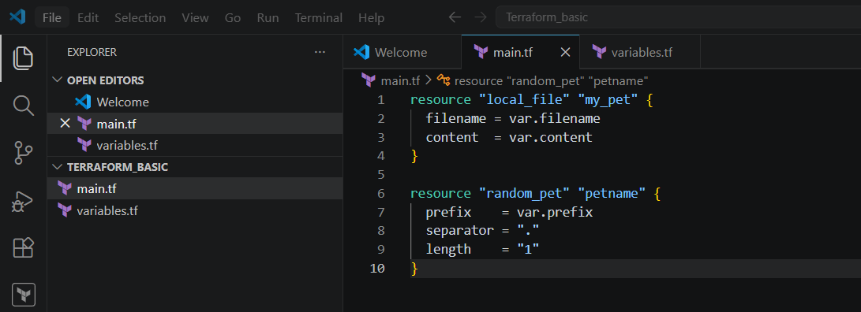

Step 3: Write variables.tf
Version 1 — Only Variable Declaration
variable "filename" {
}
variable "content" {
}
variable "prefix" {
}

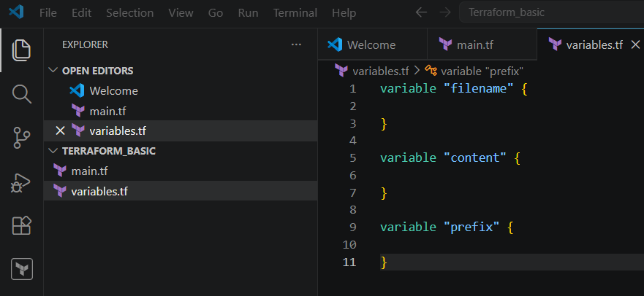

Step 4: Initialize Terraform
Open terminal inside VS Code:
terraform init
You will see:
Terraform has been successfully initialized!
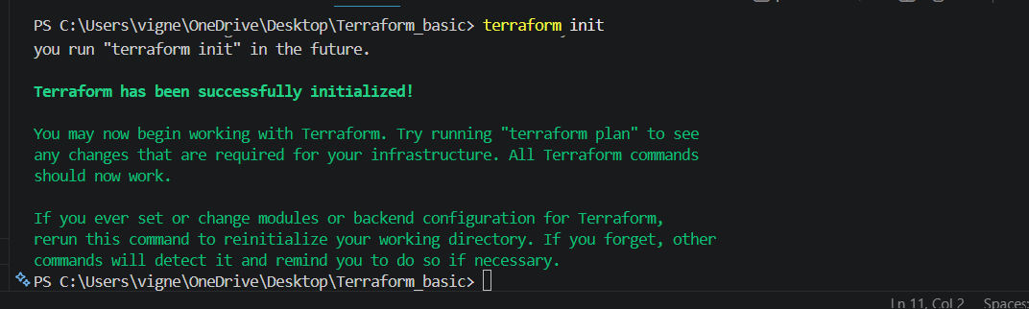

Step 5: Pass Values Using Environment Variables
Run:
Set-Item -Path env:TF_VAR_filename -Value 'wild.txt'
Set-Item -Path env:TF_VAR_content -Value 'I Love Dogs'
Set-Item -Path env:TF_VAR_prefix -Value 'MISS'

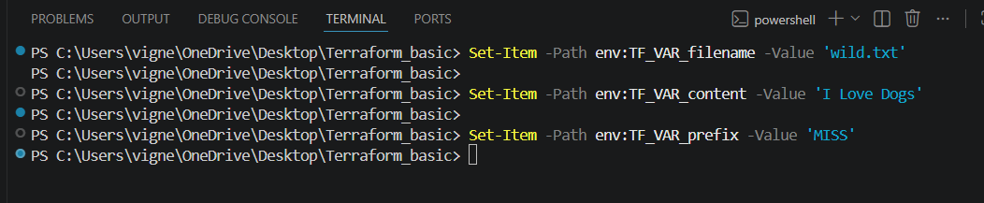
Now execute:
terraform apply
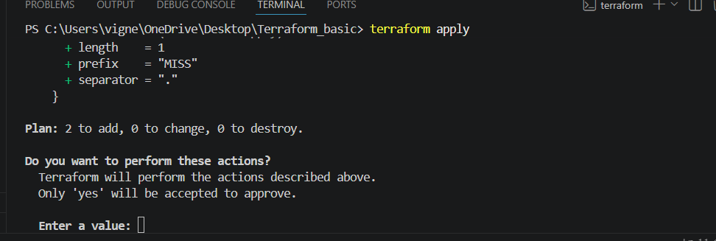
Type:
yes

Terraform creates:
wild.txt
with content:
I Love Dogs

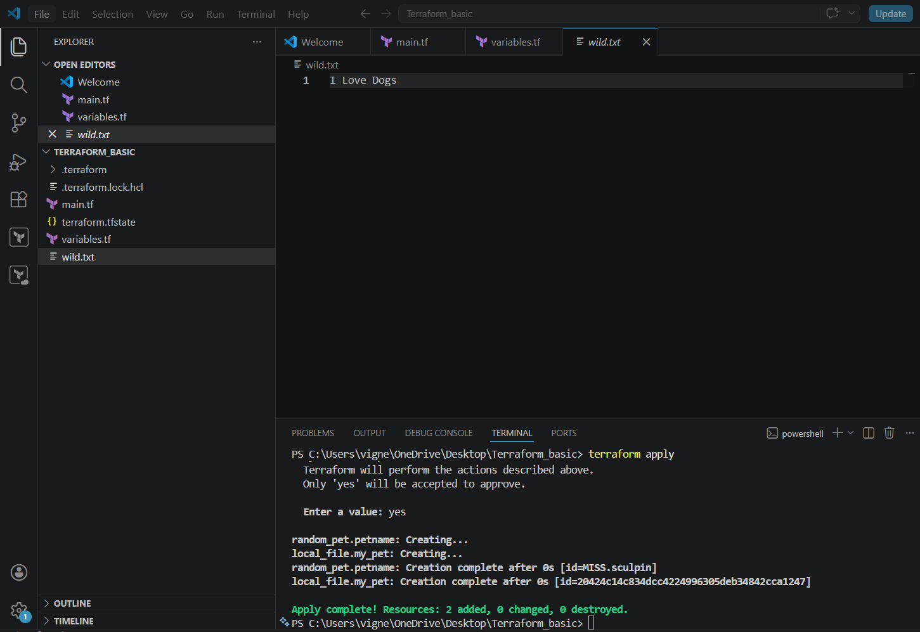

Step 6: Variable Default Values Method
Replace variables.tf with:
variable "filename" {
default = "pets.txt"
type = string
description = "File name for pets"
}
variable "content" {
default = "I love cats"
}
variable "prefix" {
default = "MR"
}
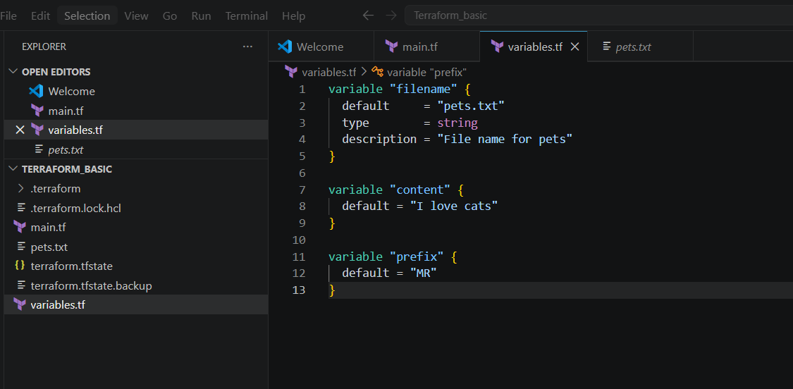
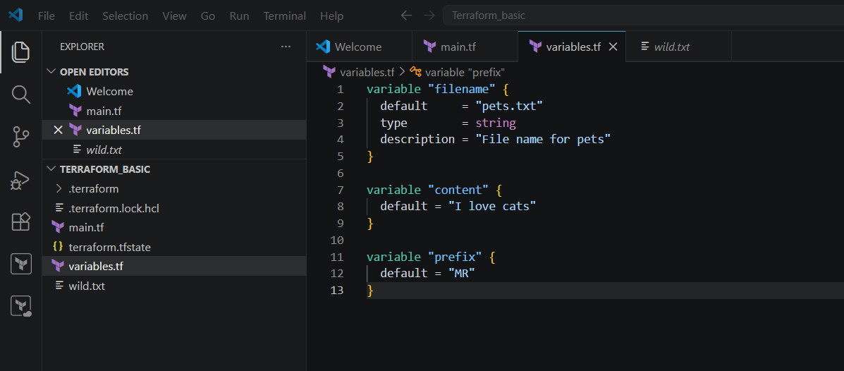
Now run:
terraform apply
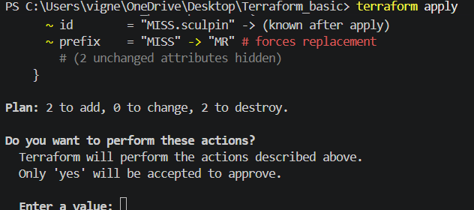
Type:
yes
Terraform automatically uses default values.
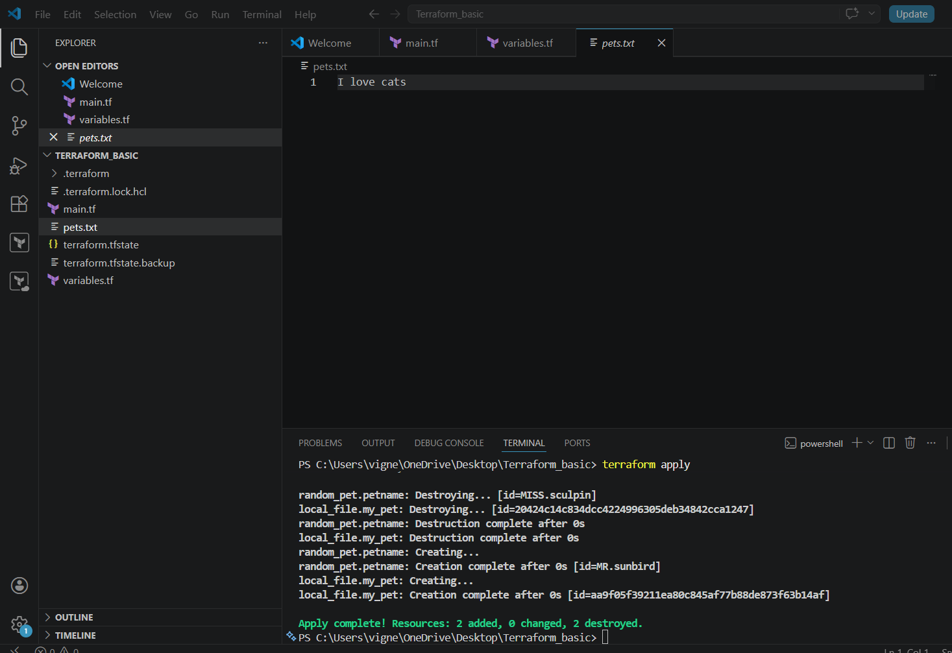

Step 7: Dynamic Random Pet Name Example
Replace main.tf with:
resource "local_file" "my_pet" {
filename = "pets.txt"
content = "My cat Name is ${random_pet.petname.id}"
}
resource "random_pet" "petname" {
prefix = "MR"
separator = "."
length = "1"
}
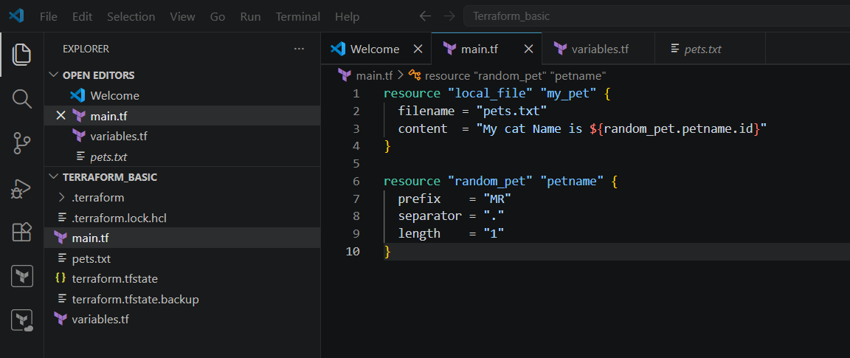
Now run:
terraform apply
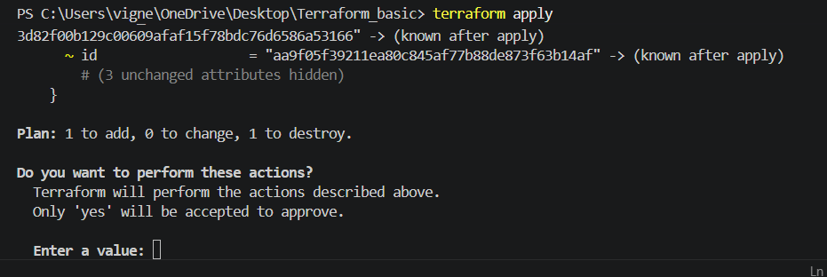
Type:
yes
Example output inside pets.txt:
My cat Name is MR.rabbit
or
My cat Name is MR.tiger
(random value changes automatically)
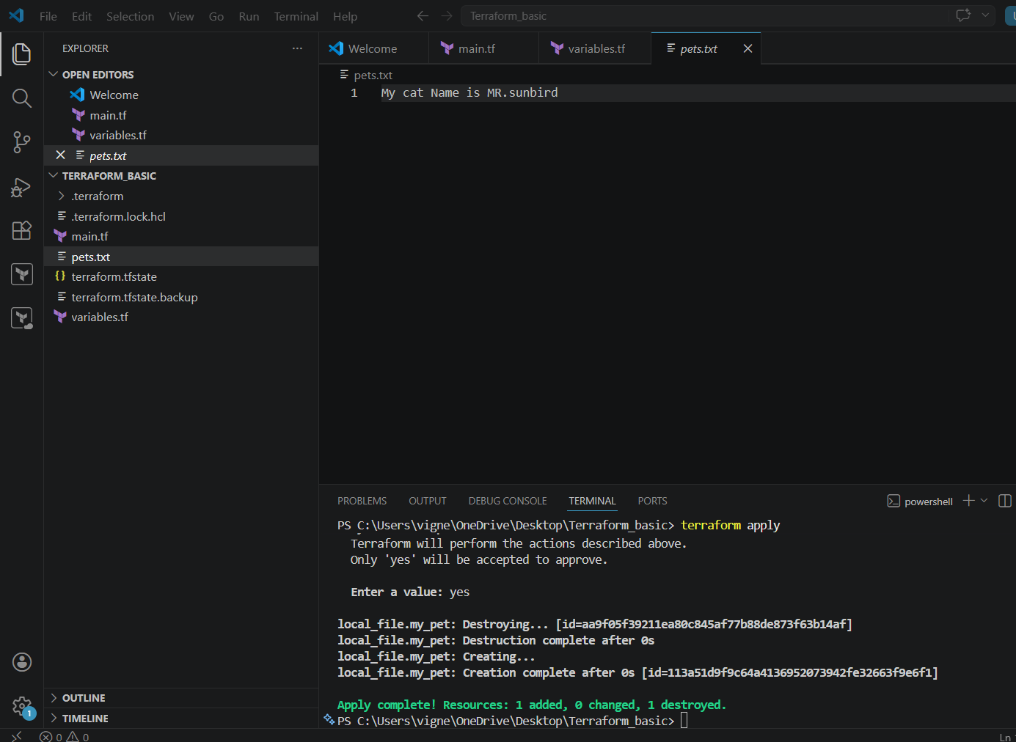

Step 8: Important Terraform Commands
Initialize
terraform init
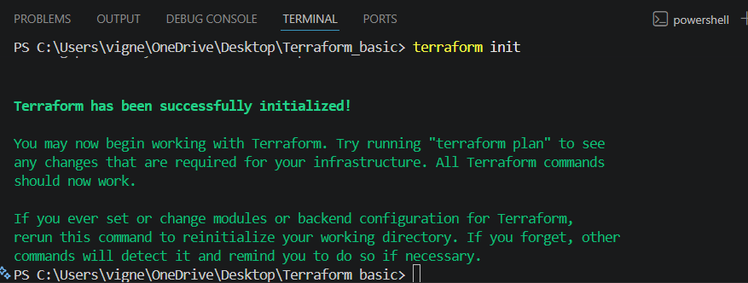
Check Execution Plan
terraform plan
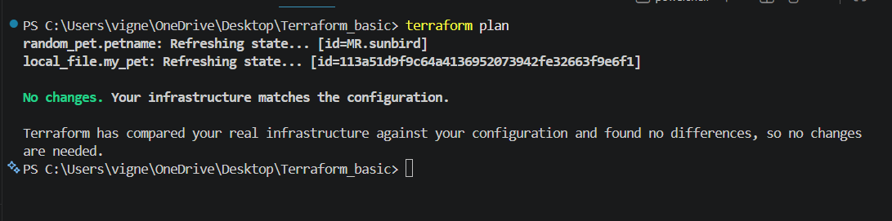
Apply Changes
terraform apply
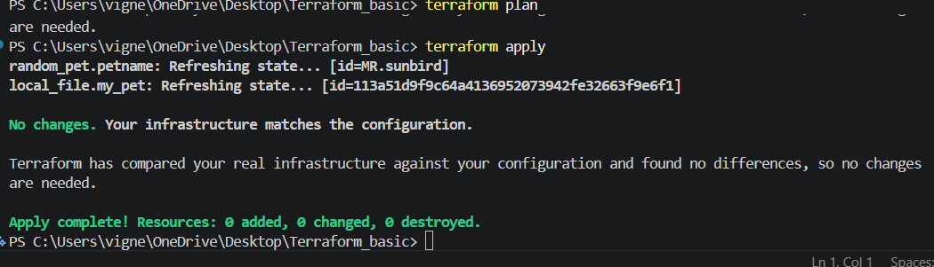
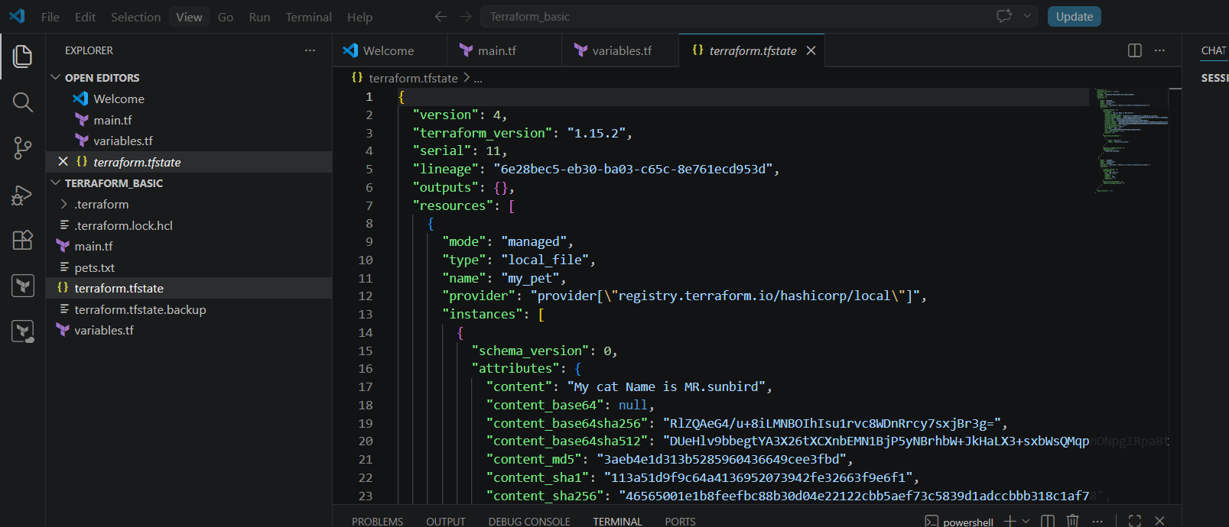
Destroy Infrastructure
terraform destroy
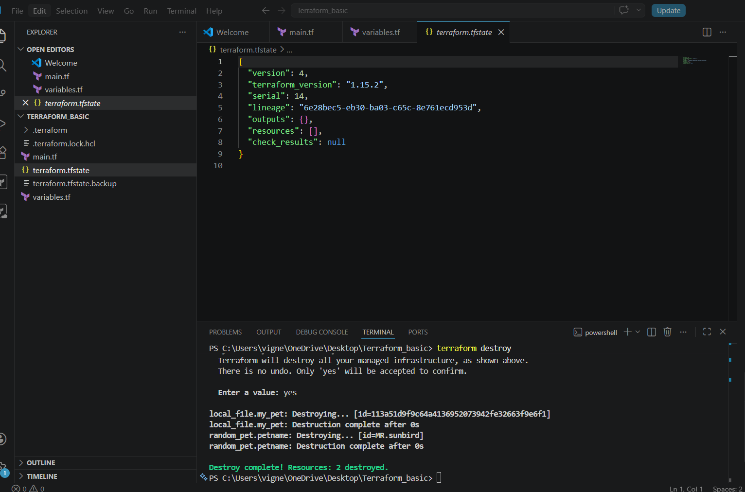

Final Folder Structure
Terraform_basic/
│
├── main.tf
├── variables.tf
├── terraform.tfstate
├── terraform.tfstate.backup
├── pets.txt
└── .terraform/

2) Integrate Terraform in Jenkins using the Terraform plugin.
Jenkins integration with Terraform allows:
- Automated infrastructure deployment
- CI/CD for infrastructure
- Auto provisioning

Architecture
Developer Pushes Code
↓
GitHub Repo
↓
Jenkins Pipeline
↓
Terraform Commands
↓
AWS Infrastructure

STEP 1 — Install Jenkins
Install Java first:
sudo yum install java-17-amazon-corretto -y
Add Jenkins repo:
sudo wget -O /etc/yum.repos.d/jenkins.repo \
https://pkg.jenkins.io/redhat-stable/jenkins.repo
Import key:
sudo rpm --import https://pkg.jenkins.io/redhat-stable/jenkins.io-2023.key
Install Jenkins:
sudo yum install jenkins -y
Start Jenkins:
sudo systemctl enable jenkins
sudo systemctl start jenkins
Check:
sudo systemctl status jenkins

STEP 2 — Install Terraform on Jenkins Server
Download Terraform:
sudo yum install -y yum-utils
sudo yum-config-manager --add-repo \
https://rpm.releases.hashicorp.com/AmazonLinux/hashicorp.repo
Install:
sudo yum -y install terraform
Verify:
terraform -version

STEP 3 — Install Terraform Plugin in Jenkins
Open Jenkins:
http://YOUR_PUBLIC_IP:8080
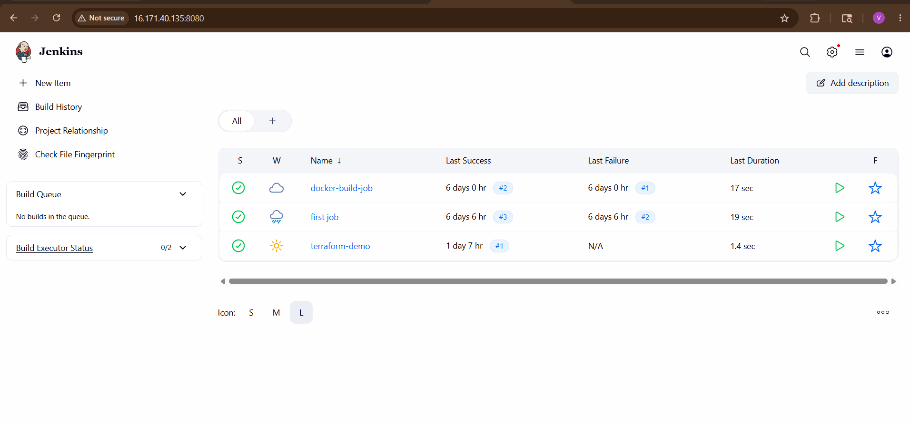Go to:
Manage Jenkins
→ Plugins
→ Available Plugins
Search:
Terraform
Install:
- Terraform Plugin
Restart Jenkins.
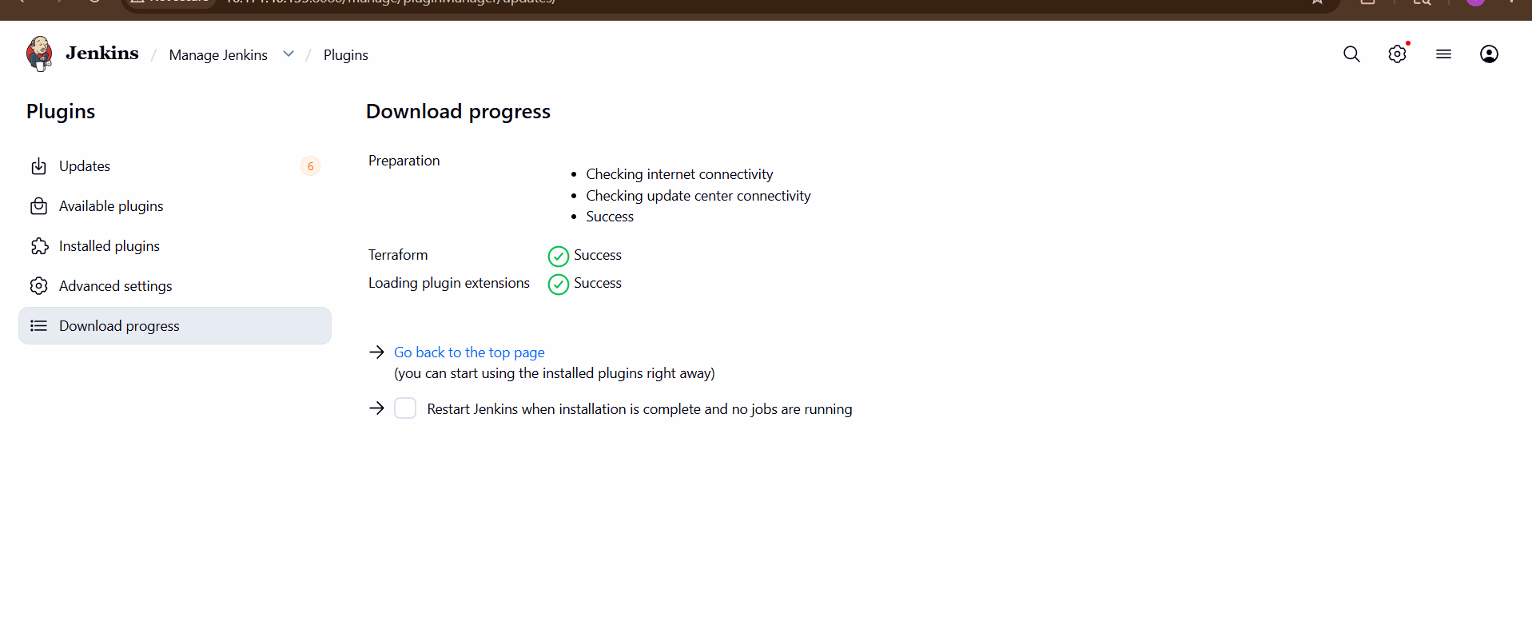

STEP 4 — Configure Terraform Tool
Go to:
Manage Jenkins
→ Tools
Find:
Terraform
Add:
Name: terraform
Install automatically: checked
Version: latest
Save.
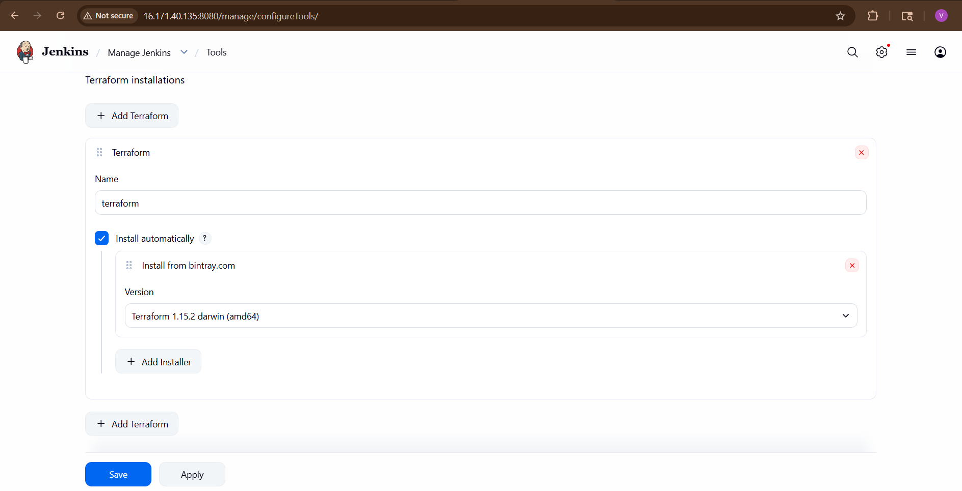

STEP 5 — Install AWS Credentials
On Jenkins server:
aws configure
Enter:
- Access key
- Secret key
- Region
Test:
aws s3 ls

STEP 6 — Create Terraform Project
Create directory:
mkdir terraform-demo
cd terraform-demo
Create main.tf
provider "aws" {
region = "eu-north-1"
}
resource "aws_instance" "demo" {
ami = " ami-0b2ab3a97a77bd35e"
instance_type = "t3.micro"
tags = {
Name = "JenkinsTerraform"
}
}
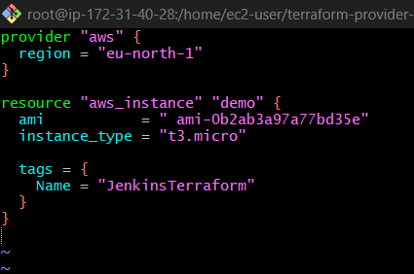

STEP 7 — Push Code to GitHub
Initialize Git:
git init
Add files:
git add .
git commit -m "terraform project"
Push to GitHub.
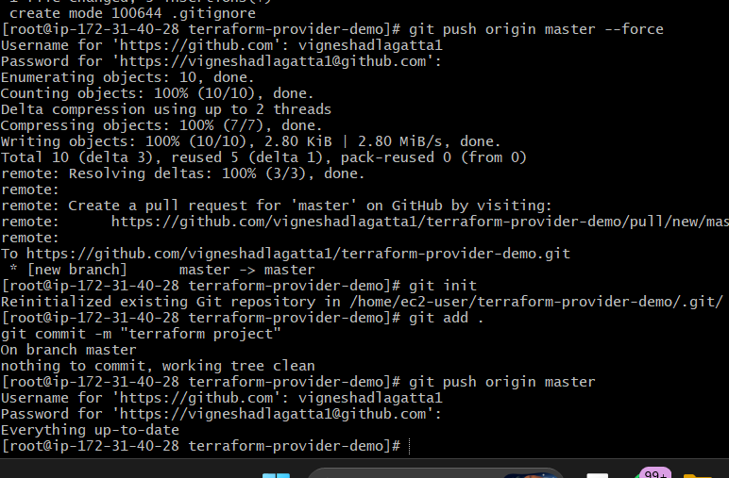

STEP 8 — Create Jenkins Pipeline Job
Go to:
New Item
Select:
Pipeline
Name:
terraform-pipeline
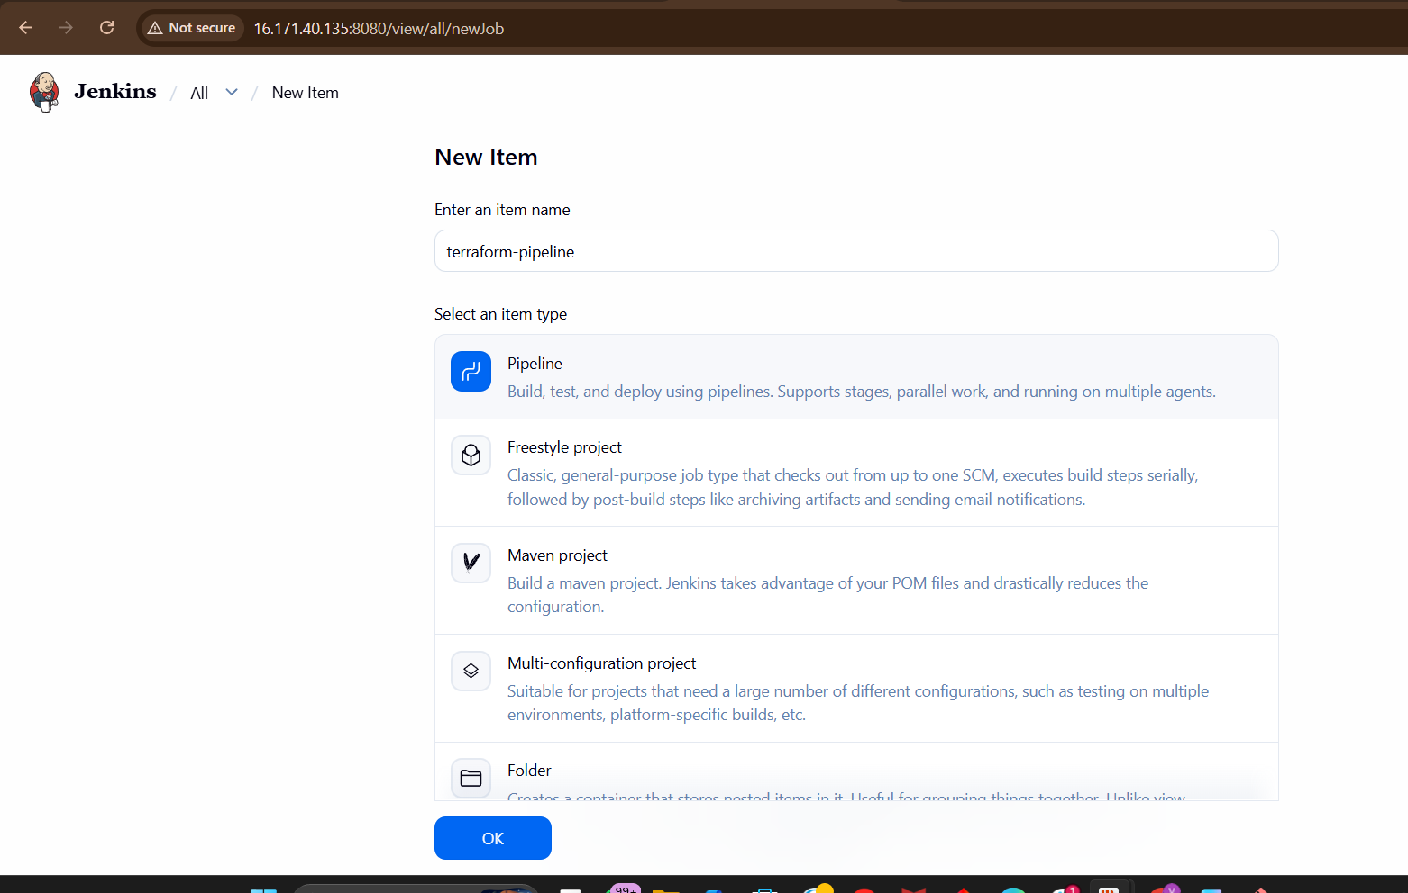

STEP 9 — Configure Pipeline Script
Add this Pipeline:

pipeline {
agent any
tools {
terraform 'terraform'
}
environment {
AWS_DEFAULT_REGION = 'eu-north-1'
}
stages {
stage('Clone Repo') {
steps {
git 'https://github.com/vigneshadlagatta1/terraform-provider-demo.git'
}
}

stage('Terraform Init') {
steps {
withCredentials([[
$class: 'AmazonWebServicesCredentialsBinding',
credentialsId: 'aws-creds'
]]) {
sh 'terraform init'
}
}
}
stage('Terraform Validate') {
steps {
withCredentials([[
$class: 'AmazonWebServicesCredentialsBinding',
credentialsId: 'aws-creds'
]]) {
sh 'terraform validate'
}
}
}
stage('Terraform Plan') {
steps {
withCredentials([[
$class: 'AmazonWebServicesCredentialsBinding',
credentialsId: 'aws-creds'
]]) {
sh 'terraform plan'
}
}
}

stage('Terraform Apply') {
steps {
withCredentials([[
$class: 'AmazonWebServicesCredentialsBinding',
credentialsId: 'aws-creds'
]]) {
sh 'terraform apply -auto-approve'
}
}
}
}
post {
success {
echo 'Terraform Infrastructure Deployment Successful!'
}
failure {
echo 'Terraform Deployment Failed!'
}
}
}
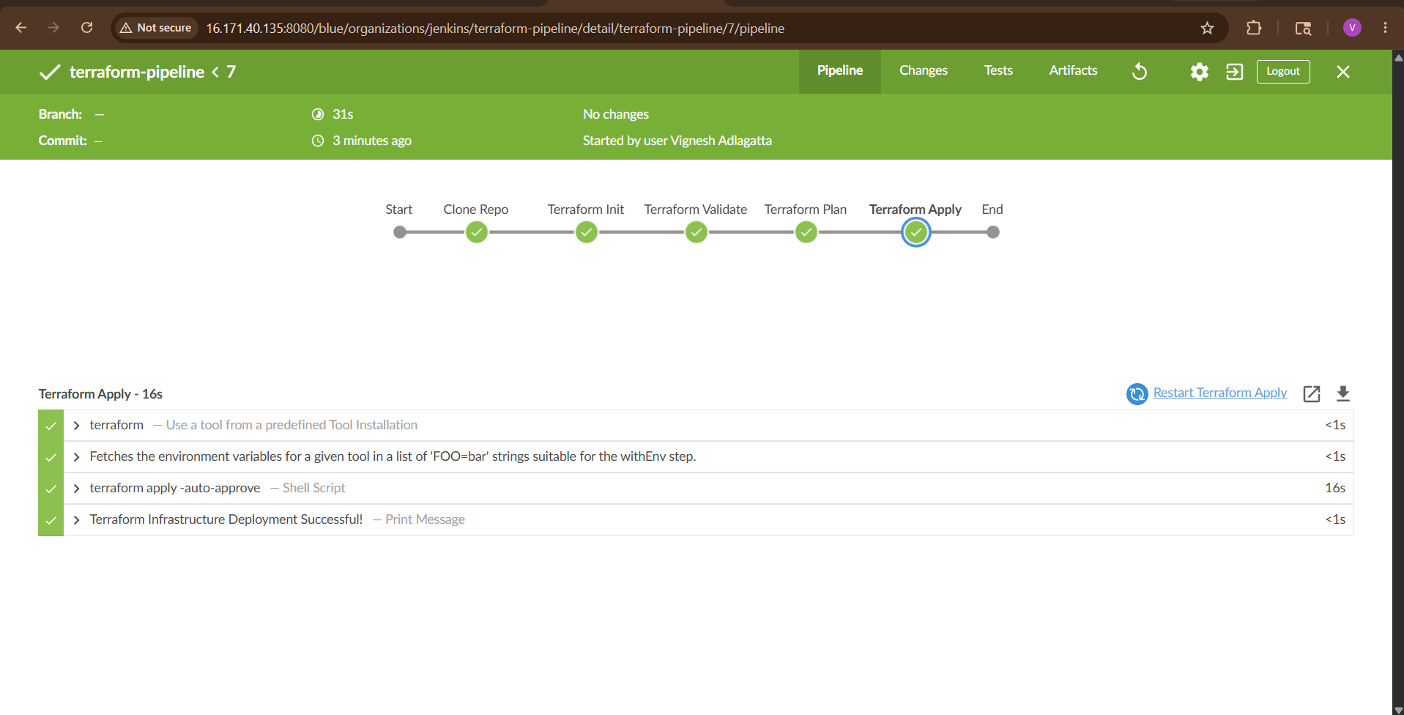

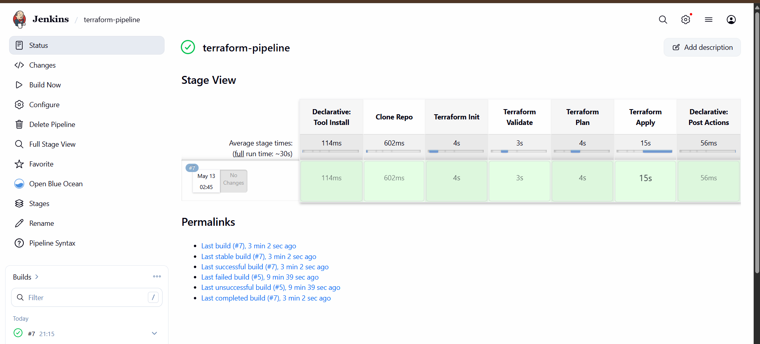

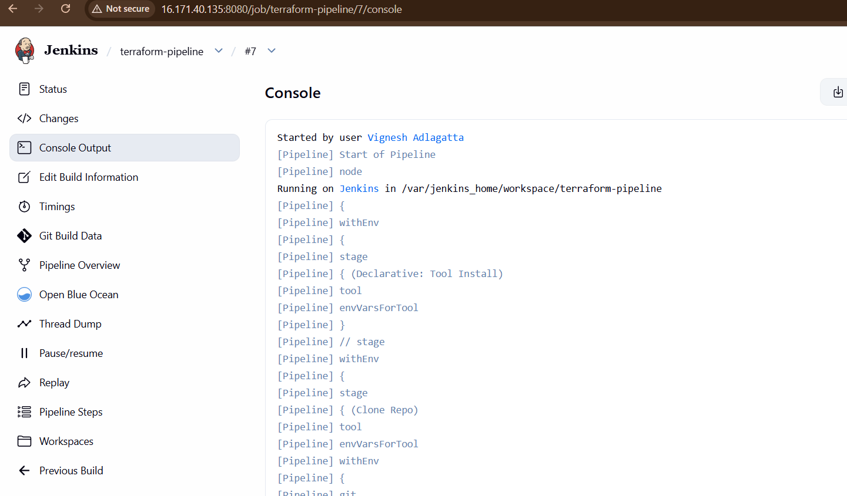

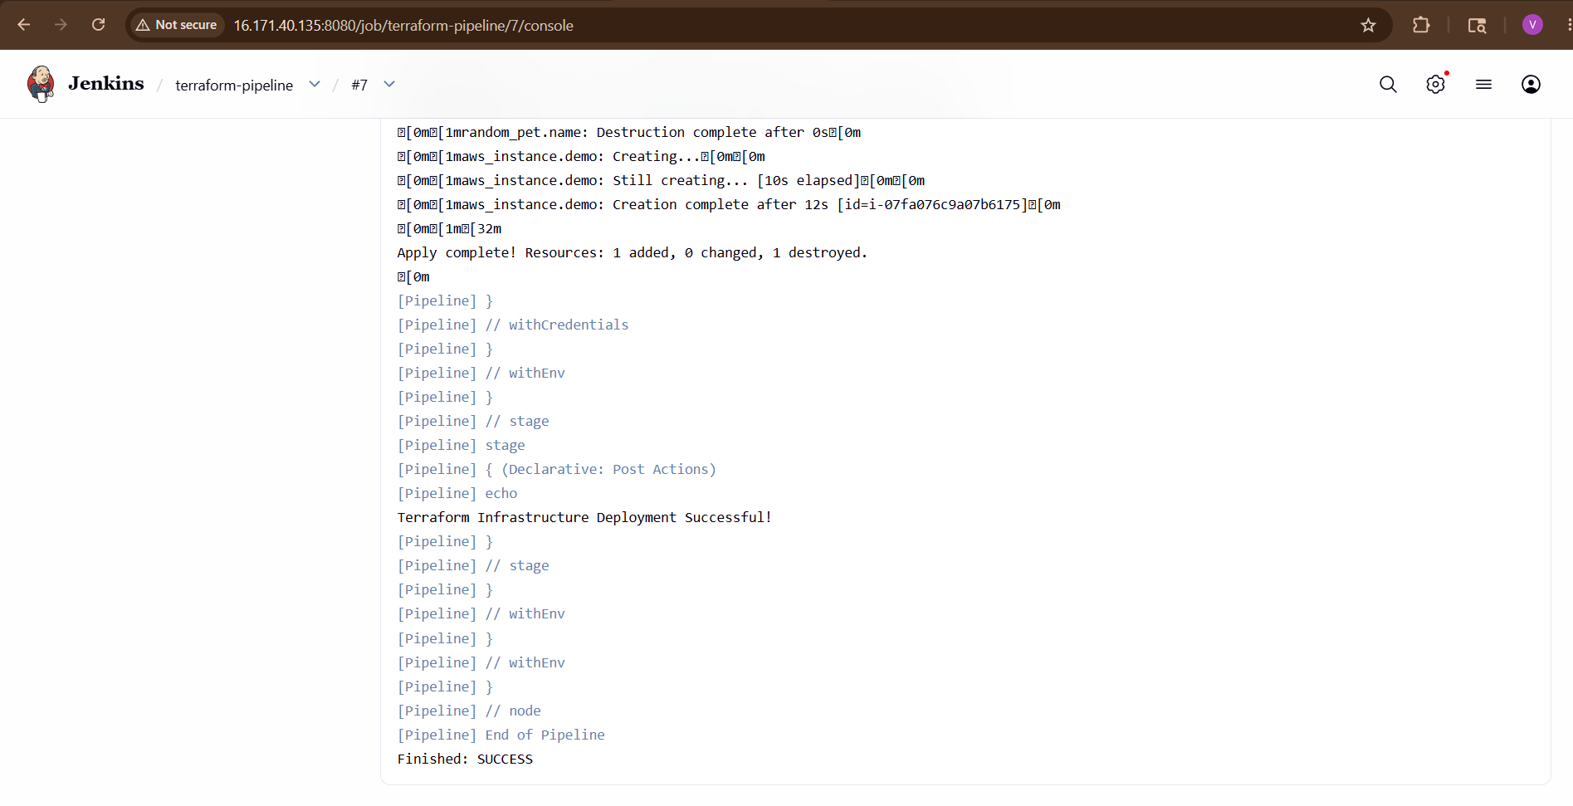
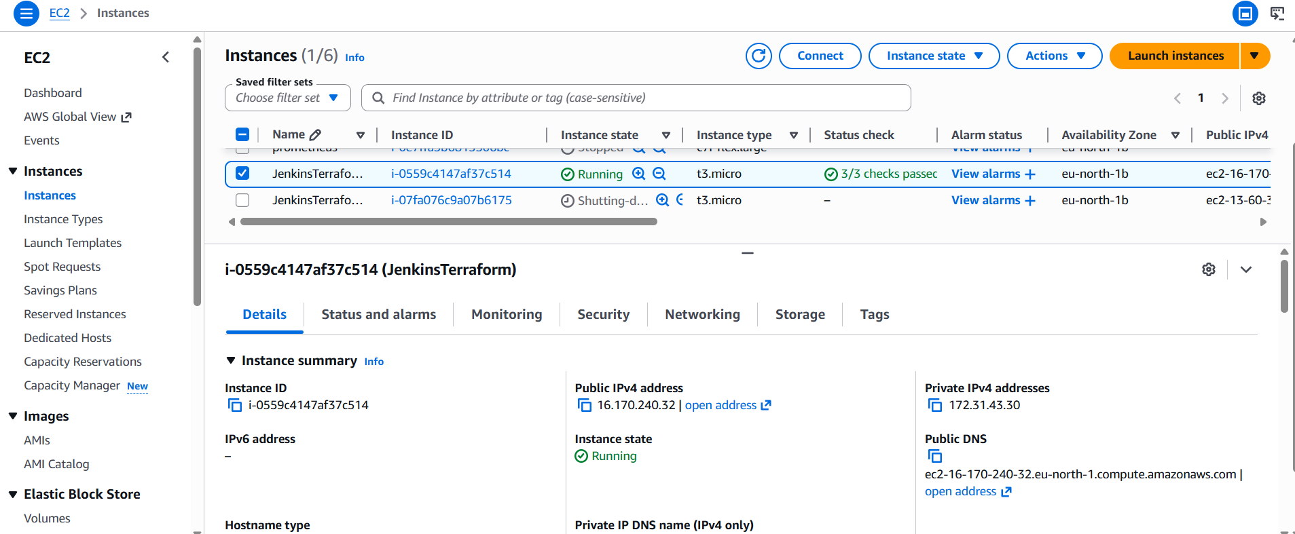

STEP 10 — Build Pipeline
Click:
Build Now
Pipeline automatically:
- Clones repo
- Initializes Terraform
- Validates code
- Creates execution plan
Deploys infrastructure

3) Create one Jenkins job using Maven Project for the code below with two stages:

Stage 1: Git clone

Stage 2: Maven Compilation Code: https://github.com/betawins/java-Working-app.git

Jenkins Maven Project Setup
Goal:
- Stage 1: Git Clone
- Stage 2: Maven Compilation

Step 1: Start Jenkins
Open Jenkins in browser:
http://<JENKINS-IP>:8080
Example:
http://localhost:8080
Login to Jenkins.

Step 2: Install Required Tools
We need:
- Java
- Maven
- Git
- Jenkins Plugins

Step 3: Install Jenkins Plugins
Go to:
Manage Jenkins
→ Plugins
→ Available Plugins

Install:
- Maven Integration Plugin
- Git Plugin
Restart Jenkins if required.

Step 4: Configure Java in Jenkins
Go to:
Manage Jenkins
→ Tools
Under JDK Installations:
Click:
Add JDK
Configure:
Name: jdk17
JAVA_HOME: /usr/lib/jvm/java-17-openjdk
(Use your actual Java path)
Check Java path:
which java
OR
readlink -f $(which java)

Step 5: Configure Maven in Jenkins
In same Tools section:
Under Maven Installations
Click:
Add Maven
Configure:
Name: maven3
Install automatically ✓
Version: Maven 3.9.x
Save.

Step 6: Create Maven Project Job
Go to Jenkins Dashboard.
Click:
New Item
Enter:
java-maven-build
Select:
Maven Project
Click:
OK
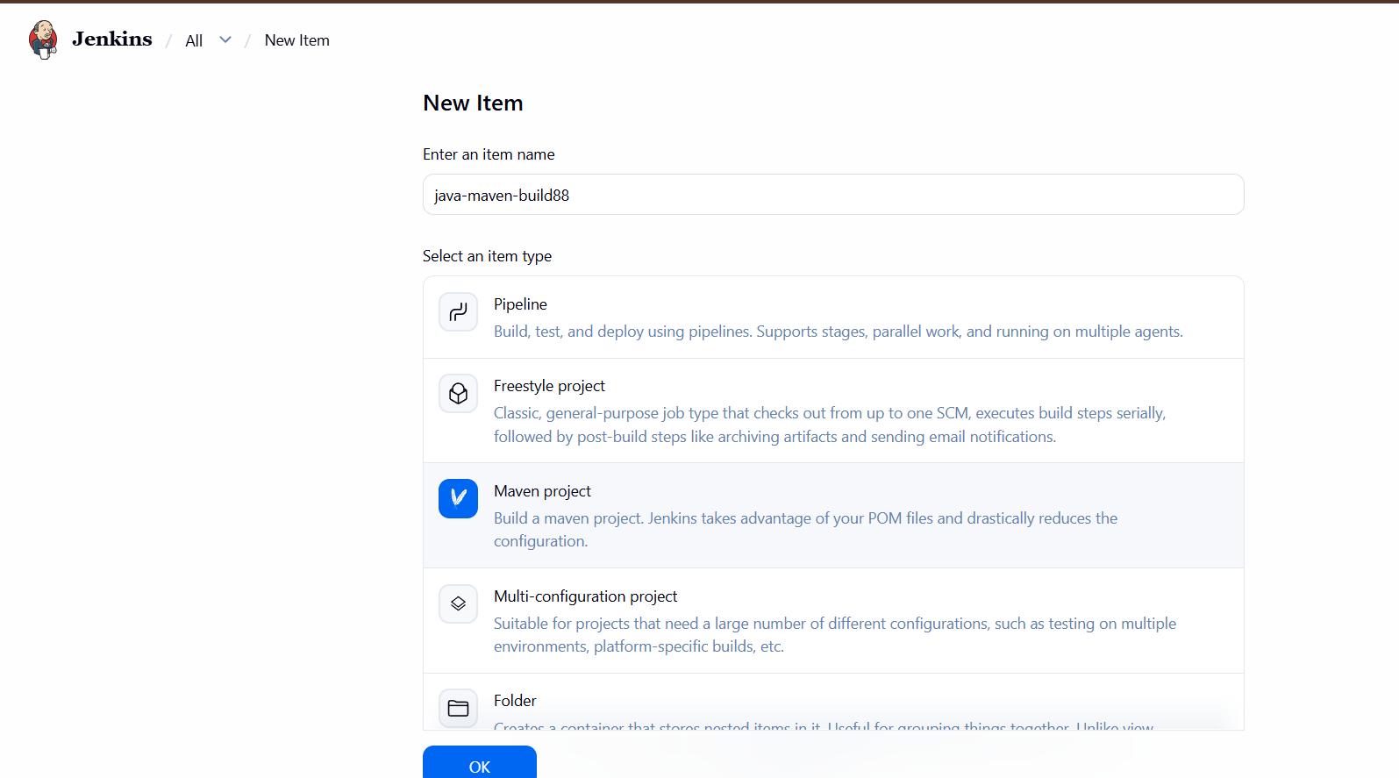

Step 7: Configure Git Repository
Scroll to:
Source Code Management
Select:
Git
Repository URL:
https://github.com/betawins/java-Working-app.git
Branch:
*/main
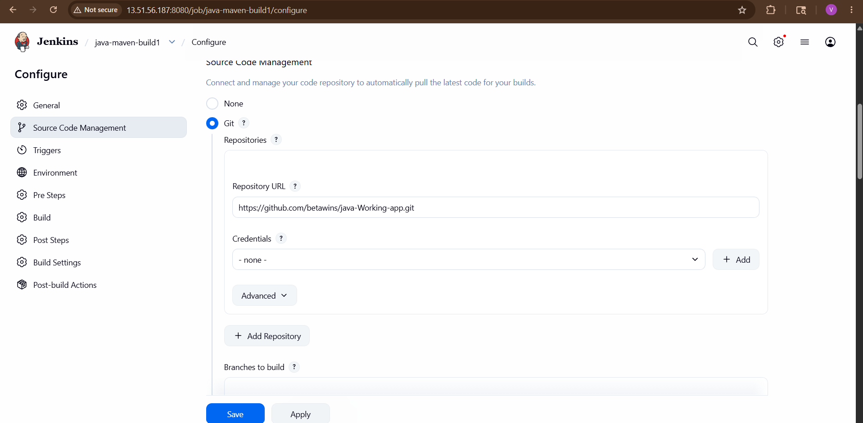
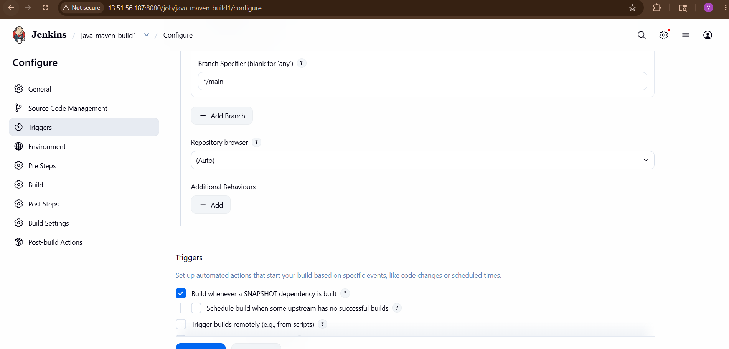

Step 8: Configure Build Triggers (Optional)
You can leave default.
OR select:
Build periodically
if required.

Step 9: Configure Maven Build
Scroll to:
Build
Under:
Root POM
Enter:
pom.xml
Under:
Goals and options
Enter:
clean compile
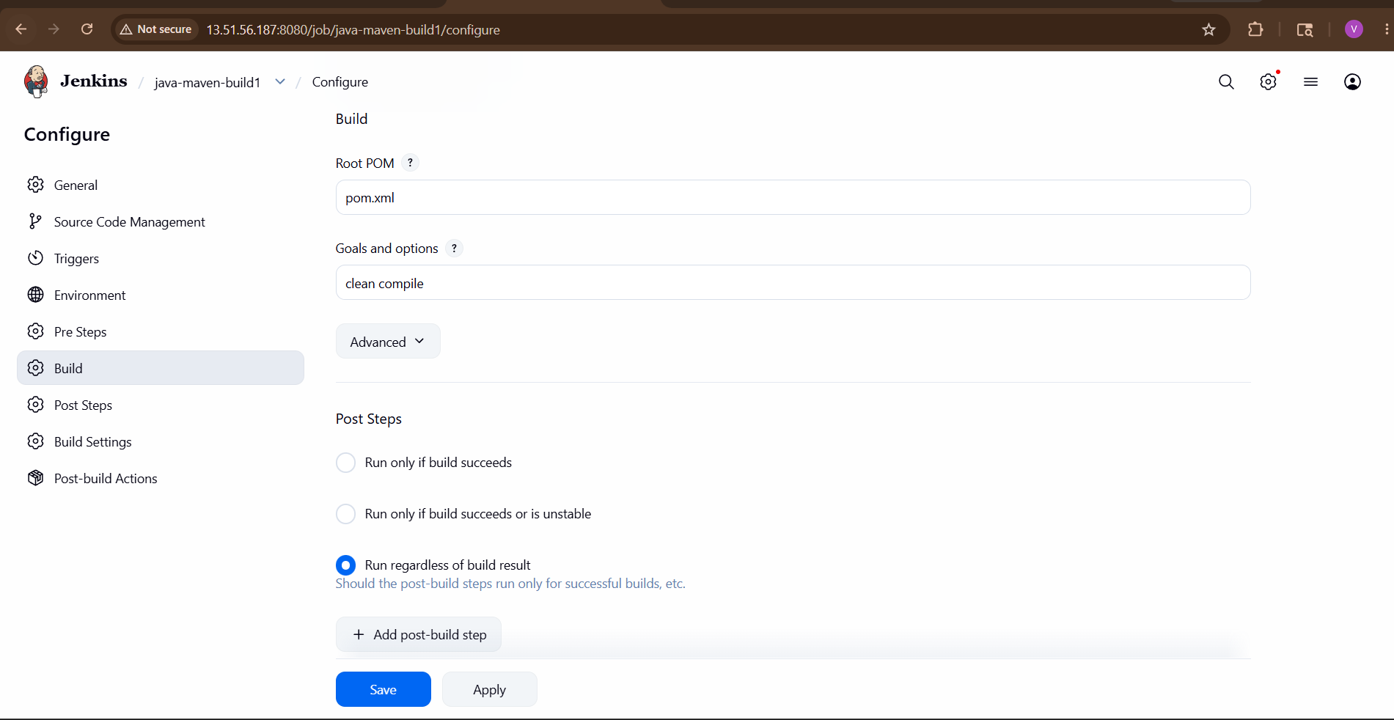
Explanation:
Command | Purpose
clean | Removes old build files
compile | Compiles Java code

Step 10: Save Job
Click:
Save

Step 11: Build the Job
Click:
Build Now
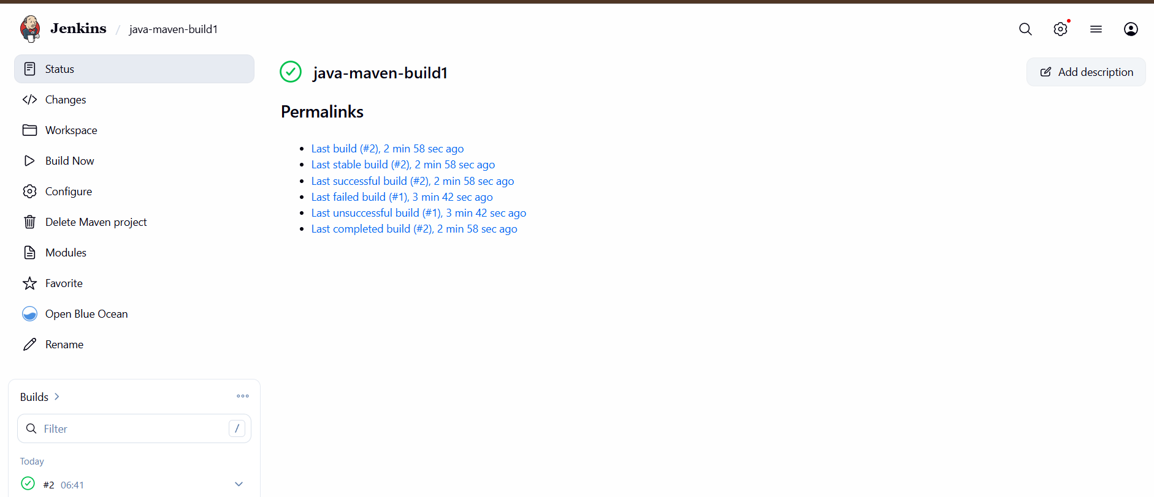

Stage 1 — Git Clone
Jenkins automatically performs Git clone.
Console Output:
Cloning the remote Git repository
Fetching upstream changes from https://github.com/betawins/java-Working-app.git
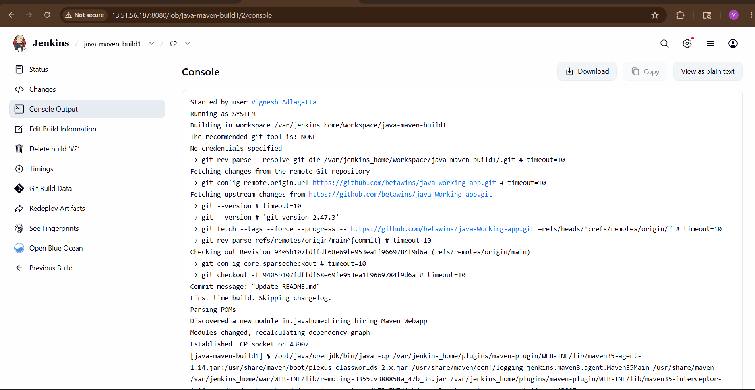
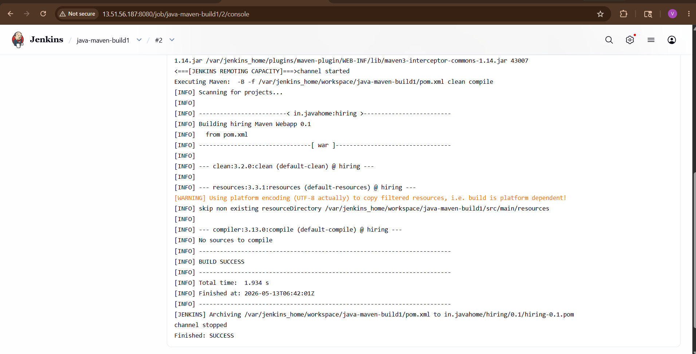

Stage 2 — Maven Compilation
Jenkins runs:
mvn clean compile
Console Output:
[INFO] Compiling 5 source files
[INFO] BUILD SUCCESS
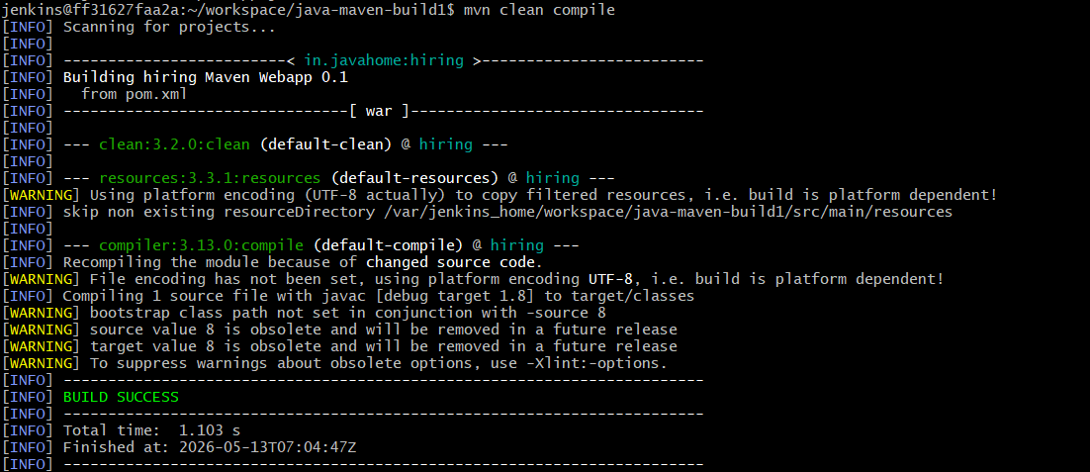

Expected Build Flow
Stage 1:
Git Clone
↓
Stage 2:
Maven Compilation
↓
BUILD SUCCESS

Verify Workspace
Go to:
Job
→ Workspace
You will see:
src/
pom.xml
target/
Verify Compiled Files
Inside:
target/classes
Compiled .class files will be generated.
Complete Build Architecture
GitHub Repository
↓
Jenkins Maven Project
↓
Git Clone
↓
Maven Compile
↓
Target Build Files

Maven Lifecycle Used
clean → compile
Meaning:
Phase | Work
clean | Deletes old target folder
compile | Compiles Java source code

Final Result
You successfully created:
- Jenkins Maven Project
- Git Integration
- Maven Compilation Build
- Automated Java Build Process

4) Use the same code and create a parameterized job in Jenkins with:

Stage 1: Git clone

Stage 2: Maven Compilation Code: https://github.com/betawins/java-Working-app.git

Create Parameterized Jenkins Job
Repository:
java-Working-app GitHub Repository

Goal
Create a Parameterized Jenkins Job with:
Stage | Purpose
Stage 1 | Git Clone
Stage 2 | Maven Compilation
The job will allow users to dynamically choose the Git branch during build time.

What Is a Parameterized Job?
A parameterized job allows Jenkins users to provide input values before running the build.
Example:
Branch Name = main
Jenkins uses that value during execution.

Step 1: Open Jenkins Dashboard
Browser:
http://<JENKINS-IP>:8080
Login to Jenkins.

Step 2: Create New Jenkins Job
Go to:
Dashboard
→ New Item
Job Name:
java-parameterized-build
Select:
Freestyle Project
Click:
OK
Step 3: Enable Parameterized Build
Under:
General
Enable:
This project is parameterized
Step 4: Add String Parameter
Click:
Add Parameter
→ String Parameter
Fill values:
Field | Value
Name | BRANCH_NAME
Default Value | main
Description | Enter Git branch name
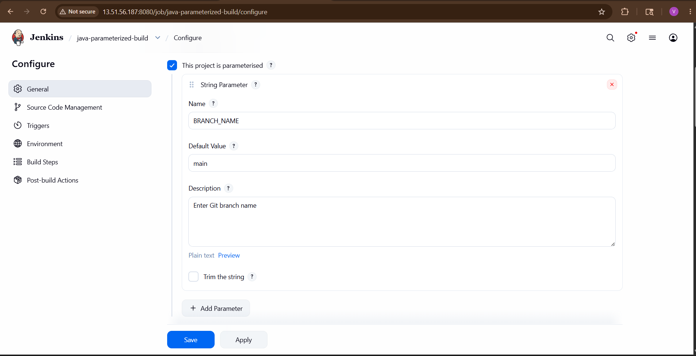

What This Parameter Does
During build, Jenkins asks:
Which Git branch should be built?
User can enter:
main
or any other branch name.

Stage 1 — Git Clone

Step 5: Configure Git Repository
Go to:
Source Code Management
Select:
Git
Repository URL:
https://github.com/betawins/java-Working-app.git
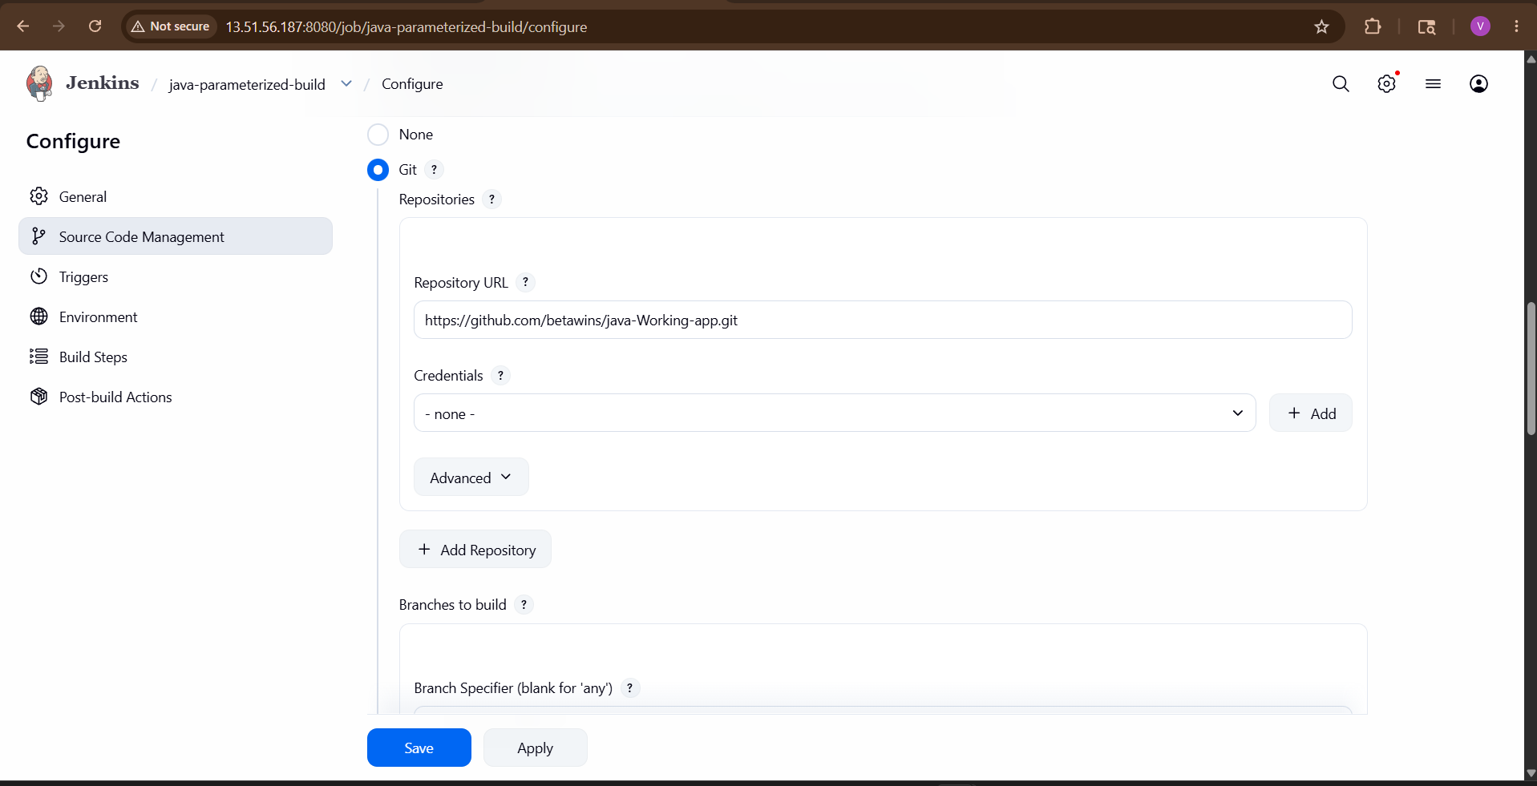

Step 6: Configure Dynamic Branch
Under:
Branches to build
Enter:
*/${BRANCH_NAME}
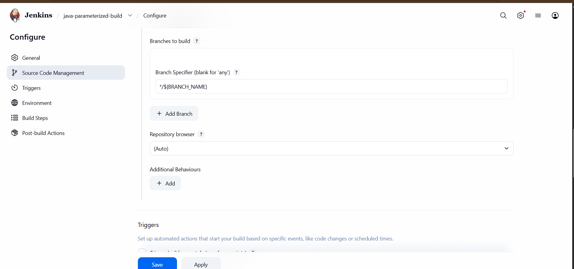

How It Works
If user enters:
main
Jenkins executes:
git checkout main

Stage 2 — Maven Compilation

Step 7: Install Maven
Amazon Linux:
sudo yum install maven -y
Ubuntu:
sudo apt install maven -y
Verify:
mvn -version

Step 8: Configure Maven in Jenkins
Go to:
Manage Jenkins
→ Tools
→ Maven Installations

Click:
Add Maven
Fill:
Field | Value
Name | Maven
Install Automatically | ✓
Save.
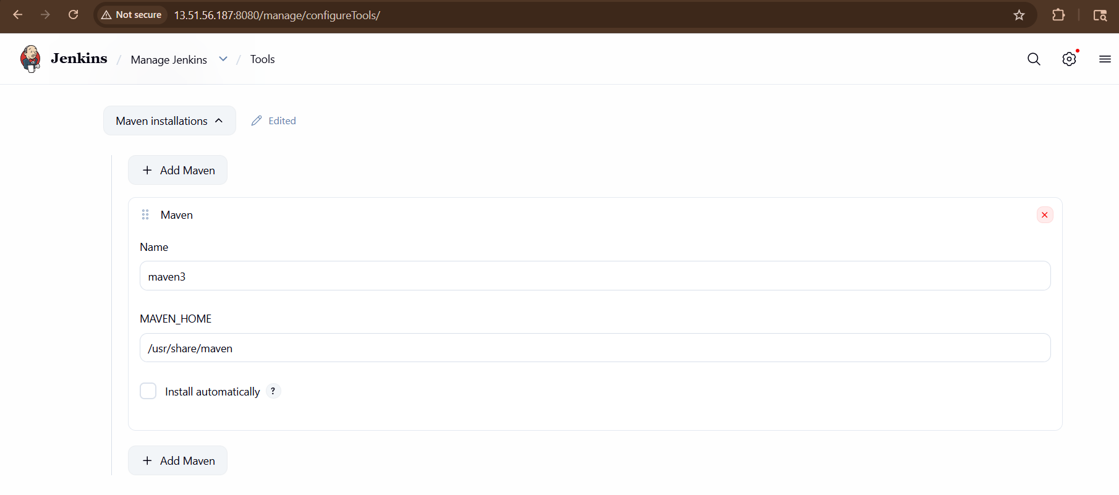
Step 9: Add Maven Build Step
Go to:
Build
Click:
Add Build Step
Select:
Invoke top-level Maven targets
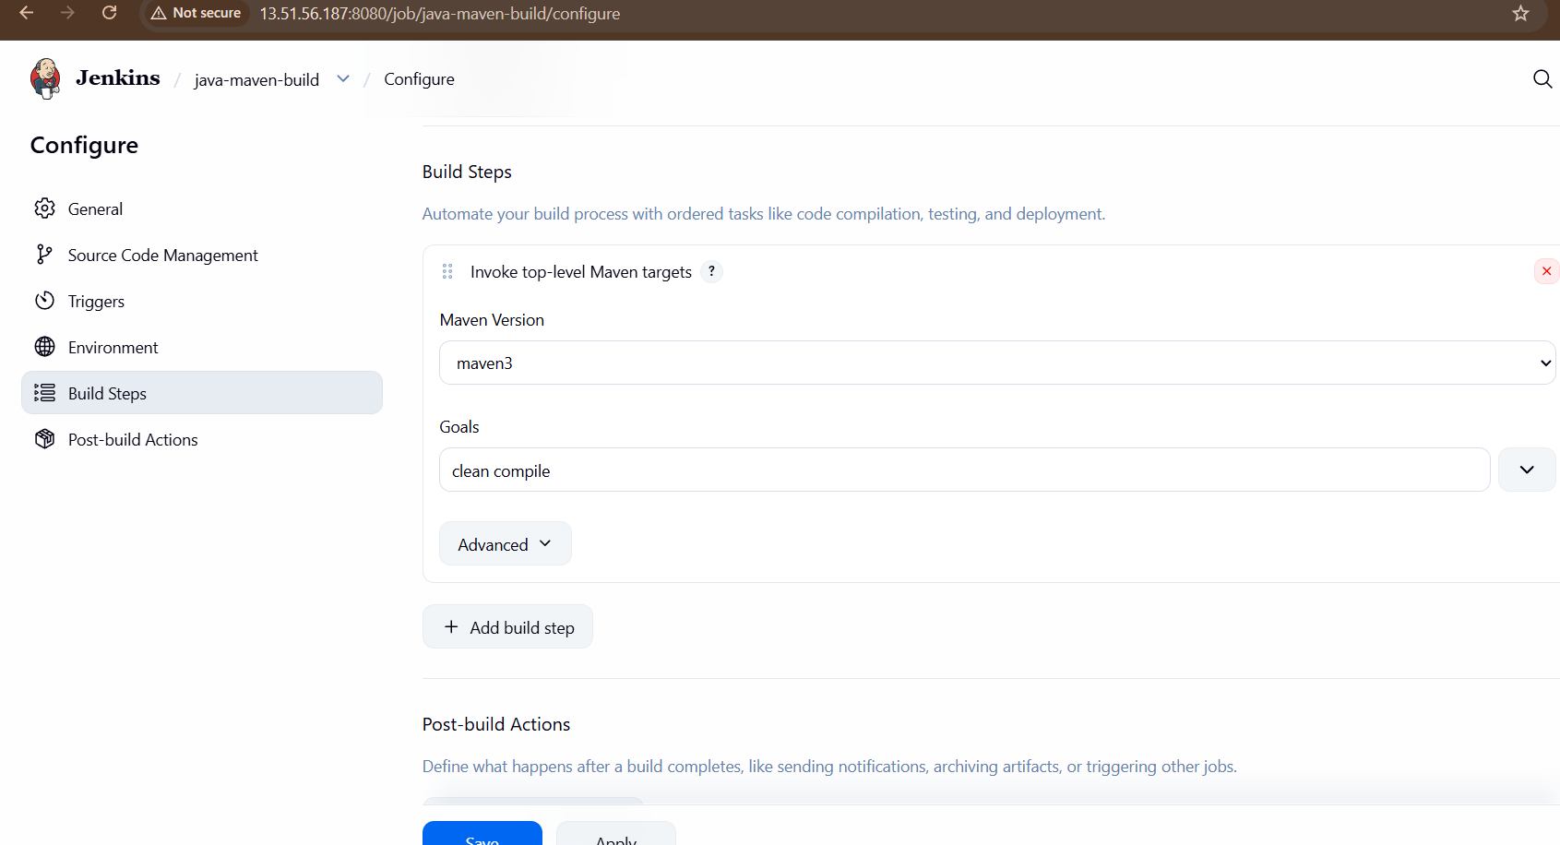

Step 10: Configure Maven Goals
Field | Value
Maven Version | Maven
Goals | clean compile

What Maven Executes
Jenkins runs:
mvn clean compile

Meaning of Commands
Command | Purpose
clean | Removes old files
compile | Compiles Java code

Step 11: Save Job
Click:
Save

Step 12: Run Parameterized Job
Click:
Build with Parameters
Enter:
main
Click:
Build
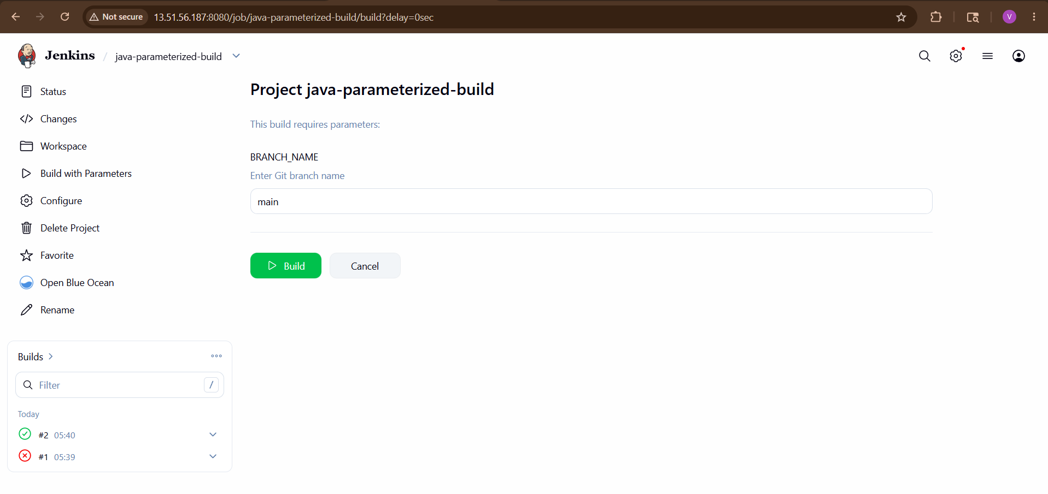
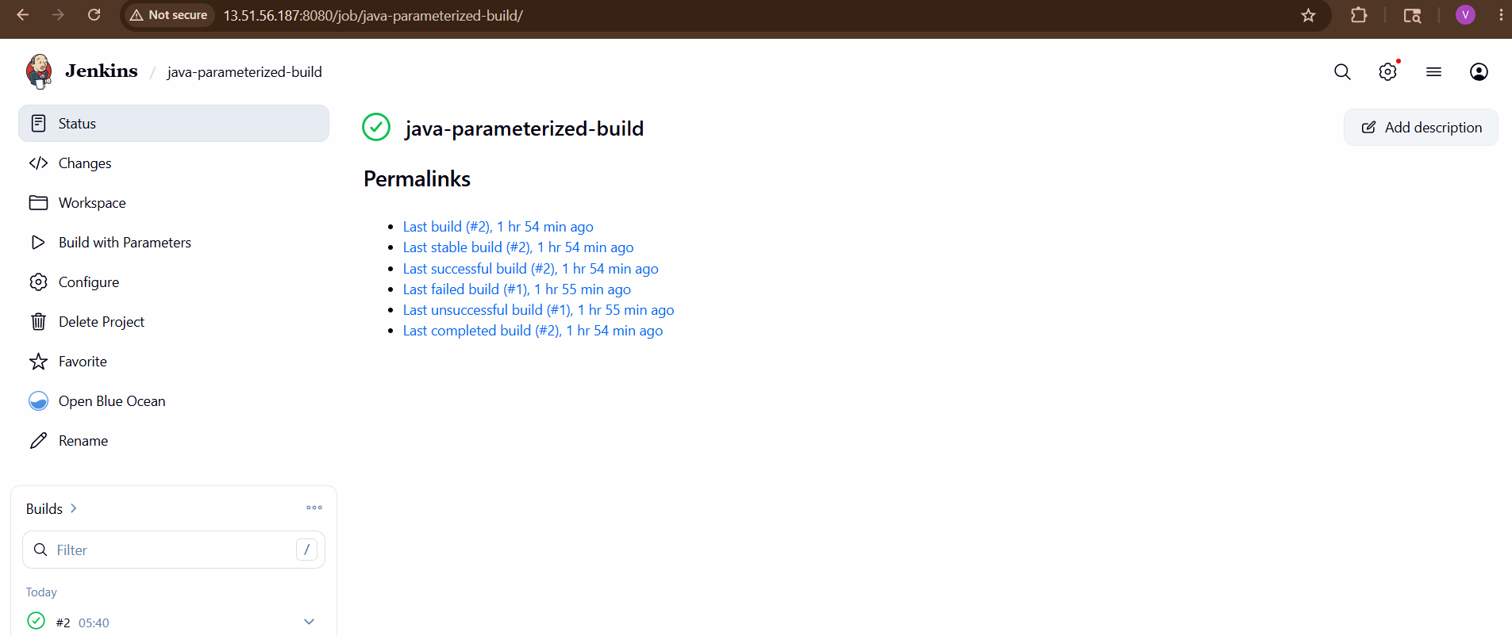

Expected Console Output
Stage 1
Cloning repository
Checking out Revision

Stage 2
mvn clean compile

Success Message
BUILD SUCCESS
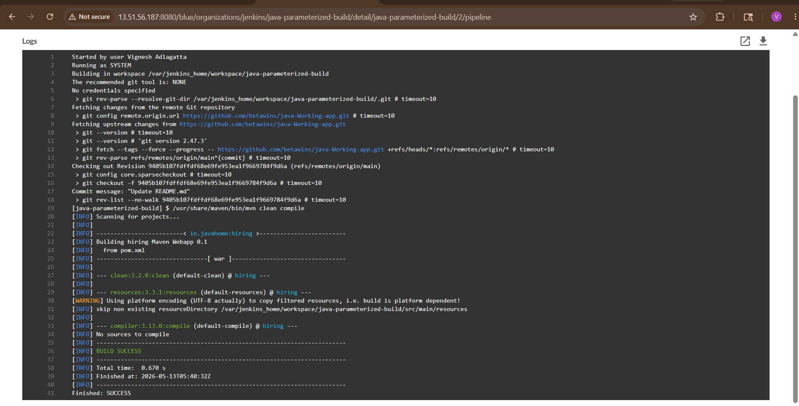

Internal Workflow
User Inputs Branch Name
↓
Jenkins Job Starts
↓
Stage 1 → Git Clone
↓
Stage 2 → Maven Compilation
↓
BUILD SUCCESS

Advantages of Parameterized Jobs
Feature |  | Benefit
Dynamic Branch Build |  | Build any branch
Flexible Deployments |  | Dev/Test/Prod
Reusability |  | One job for multiple branches
Automation |  | CI/CD ready

Final Result
You successfully created:
✅ Parameterized Jenkins Job
✅ Dynamic Git Branch Selection
✅ Stage 1 → Git Clone
✅ Stage 2 → Maven Compilation
✅ Automated Maven Build Process

5) What are the global variables in Jenkins?

Global Variables in Jenkins
Global variables in Jenkins are predefined environment variables automatically available during a Jenkins build or pipeline.
They provide useful build information such as:
- Build number
- Job name
- Workspace path
- Git branch
- Jenkins URL
- Build status
These variables help automate CI/CD workflows.

Why Global Variables Are Important
Global variables are used for:
✅ Dynamic pipelines
✅ Deployment automation
✅ Logging
✅ Notifications
✅ Artifact naming
✅ Environment management

Most Common Jenkins Global Variables
Variable |  | Description
BUILD_NUMBER |  | Current build number
BUILD_ID |  | Unique build ID
BUILD_TAG |  | Build identifier
JOB_NAME |  | Name of Jenkins job
JOB_BASE_NAME |  | Short job name
BUILD_URL |  | URL of current build
JOB_URL |  | URL of Jenkins job
JENKINS_URL |  | Jenkins server URL
NODE_NAME |  | Name of Jenkins agent/node
NODE_LABELS |  | Labels assigned to node
EXECUTOR_NUMBER |  | Executor ID
WORKSPACE |  | Workspace directory path
WORKSPACE_TMP |  | Temporary workspace
HOME |  | Jenkins user home directory
USER |  | Jenkins executing user
JAVA_HOME |  | Java installation path
PATH |  | System path
GIT_COMMIT |  | Git commit ID
GIT_BRANCH |  | Git branch name
GIT_URL |  | Git repository URL
GIT_PREVIOUS_COMMIT |  | Previous Git commit
BUILD_STATUS |  | Build result
BUILD_DISPLAY_NAME |  | Display name of build

Example of Global Variables
Suppose:
Item |  |  | Value
Job Name |  |  | java-maven-build
Build Number |  |  | 15
Then:
Variable |  |  |  |  |  | Output
BUILD_NUMBER |  |  |  |  |  | 15
JOB_NAME |  |  |  |  |  | java-maven-build

How to Print Global Variables in Jenkins
Freestyle Project
Add build step:
Execute Shell
Add:
echo "Build Number: $BUILD_NUMBER"
echo "Job Name: $JOB_NAME"
echo "Workspace: $WORKSPACE"
echo "Git Branch: $GIT_BRANCH"
echo "Build URL: $BUILD_URL"
Build the job.
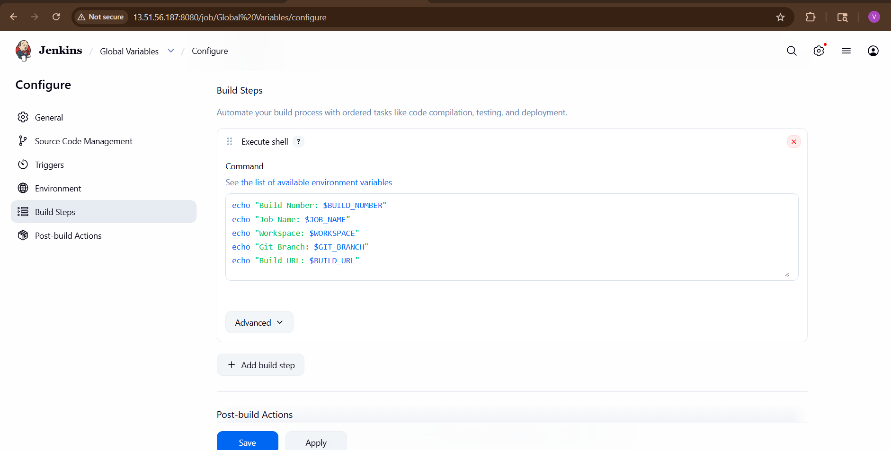

Sample Output
Build Number: 25
Job Name: java-maven-build
Workspace: /var/lib/jenkins/workspace/java-maven-build
Git Branch: origin/main

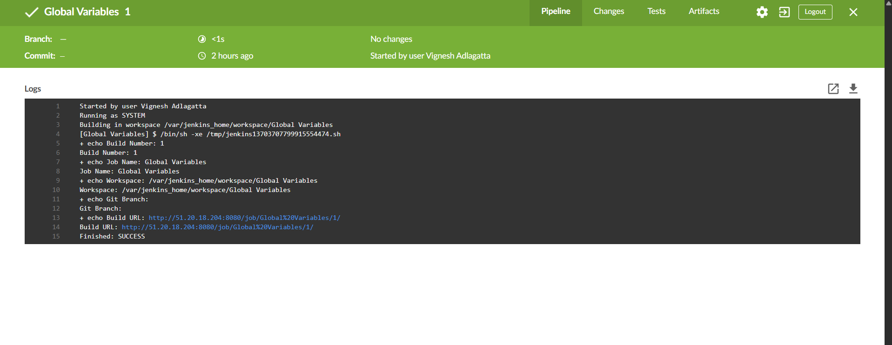

Global Variables in Jenkins Pipeline
Example Pipeline
pipeline {
agent any
stages {
stage('Print Variables') {
steps {
sh 'echo BUILD_NUMBER: $BUILD_NUMBER'
sh 'echo JOB_NAME: $JOB_NAME'
sh 'echo WORKSPACE: $WORKSPACE'
sh 'echo GIT_BRANCH: $GIT_BRANCH'
}
}
}
}

Important Git Variables
Variable | Purpose
GIT_COMMIT | Current commit ID
GIT_BRANCH | Current branch
GIT_URL | Repository URL
Example:
echo $GIT_COMMIT
Output:
9405b107fdffdf68e69fe953ea1f9669784f9d6a

Important Workspace Variables
Variable | Purpose
WORKSPACE | Current project directory
WORKSPACE_TMP | Temp workspace
Example:
echo $WORKSPACE
Output:
/var/jenkins_home/workspace/java-parameterized-build

Important Build Variables
Variable | Purpose
BUILD_NUMBER | Incremental build ID
BUILD_ID | Unique build timestamp
BUILD_TAG | Build label
Example:
echo $BUILD_NUMBER
Output:
12

Real-Time Usage Example
Dynamic Artifact Naming
artifact-$BUILD_NUMBER.war
Generated:
artifact-15.war

Deployment Example
scp target/app.war server:/opt/tomcat/webapps/app-$BUILD_NUMBER.war
Each deployment gets a unique version.

How to See All Environment Variables
Add build step:
printenv
OR
env
This displays all Jenkins global variables.

Difference Between Environment Variables and Global Variables
Environment Variables | Global Variables
OS level variables | Jenkins predefined variables
Defined manually | Automatically available
Example: JAVA_HOME | Example: BUILD_NUMBER

Final Summary
Global variables in Jenkins are automatically available variables used during builds and pipelines for:
✅ Build information
✅ Git integration
✅ Workspace management
✅ Deployment automation
✅ Dynamic CI/CD pipelines

